
MDMLG Auditor
Annual Report
7/1/21 – 7-31-22

I received the financial records consisting of the following: banks statements, register, PayPal transaction reports, reimbursement request forms, and bank deposit slips from Andrea Rogers-Snyr, MDMLG Treasurer. The audit was conducted mid-September 2022, and the period of the documents covered July 1, 2021 through July 31, 2022.

The check numbers included 1651 through 1657. Register deposits matched the bank statements, check stubs matched the check amounts, the check sequence was correct and all checks were accounted for. Reimbursement forms were complete and accompanied by receipts or alternate documentation where appropriate. PayPal deposits and transfers matched the documentation from the register and the bank statements.

There were no outstanding transactions (uncashed checks) from the last audit. The register balance matches the bank statement balance. The checking account balance as of July 31, 2022 is $10,975.05.

Form 990-N e-postcard was filed electronically for the 2021 tax year.

The books are in good order. Beginning next year (2023), based on a discussion with the treasurer, it is recommended the time period covered by the audit align with MDMLG’s fiscal year which runs August 1st – July 31st.

Respectfully submitted,

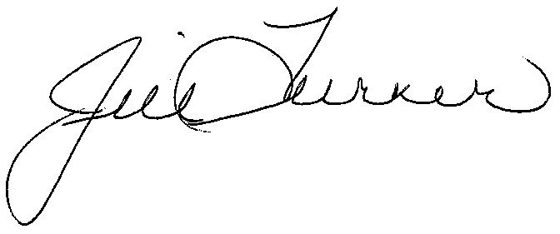
Jill Turner
Auditor, MDMLG

